Dropbox https://www.dropbox.com/scl/fo/52wvv9217z8j7pvnss0kc/AHakwE7vGGoi50RjOU-rxx0?rlkey=x9zcm86mjp8xwz8ey2wtg5os0&dl=0
Characters and Time layers
- William III “Yorkshire Feast Song” (1689) composed for coronation of William Orange and Mary by English composer Henry Purcell, who was very commissioned to produce ceremonial music for coronation of royalties and social events. Logic Pro: Vienna orchestra mix
“William himself, unlike James, remained reluctant to intervene in Ireland. By February 1689 a group of Irish Protestants in England had given up waiting for William to act and were prepared to return to Ireland if James would give them terms. William’s reluctance to become involved in Ireland can best be explained by his European background. The Dutch wars of the 1670s were a defining moment in the life of William of Orange, for they gave him a profound hatred of King Louis XIV and of France. The hatred was sharpened after 1682 when French troops occupied William’s principality of Orange in south-east France. The battle- lines of European politics hardened as England joined the War of the League of Augsburg against France on 12 May 1689. This war was to be William’s priority for the remainder of his military life, and Ireland may be seen as a small part of it. William found himself in a league with a wide range of anti- French powers, including the papacy, which viewed Louis XIV’s ambitions as dangerous for European stability. Such alliances explain why many Catholic European powers, not least the papacy, welcomed the defeat of Louis’s ally, King James, at the battle of the Boyne.”[1, p. 291] … “Louis could not be left with Ireland as a jumping -off point for a possible invasion of England.” (p. 292, Gillespie)
- James II in connection with Ludovic XIV, French music. I found march by John Playford (1623- 1686), who was specialising on military marches of England of that time, specifically named : “James the Second & Prince Ruperts March” arr. Hans Jorgen Messerschmidt (IMSLP library). Logic Pro: trumpets
“By 1689 James’s relationship with his Protestant subjects was disintegrating rapidly. By late January there were a growing number of declarations for William from Ulster. On 4 January the Sligo Association declared for him, on 19 January the gentry of Antrim and Down joined them, and on 29th January the Ulster Presbyterians sent William a congratulatory address. In March Enniskillen declared for William. The most dramatic example of this accelerating breakdown of relations was the second closing of the gates of Derry against James, this time in person, on 18April 1689, which tied down Jacobite forces in north-west Ulster for five months. The Jacobite parliament with its Act of Attainder and restructuring of the land settlement speeded up the disengagement between James and what Protestant support he had left.” (17th century Ireland, Raymond Gillespie, Department of Modern History, National University of Ireland, Maynooth)

Battle
“It was within this context that William arrived at Carrickfergus, County Antrim, on 14 June 1690 with 15,000 men, a train of artillery, a printer and a war- chest of £200, 000. A Williamite force had already landed at Bangor the previous August under Marshal Schomberg and had consolidated a bridgehead in Ulster stretching as far south as Dundalk, but he had refused to engage James’s forces as his army had been ravaged by disease. William marched south, but it was James who had time on his side and was able to choose the site of engagement at the River Boyne on 1 July 1690. William had some 40,000 men in total, including mercenaries from a number of European countries. These faced a Jacobite force of probably no more than 25,000, including some French soldiers. The fighting was not particularly heavy or prolonged, a fact reflected in the modest casualties- about 1,000 on the Jacobite side and 500 Williamites.”[1, p. 292]

- Ludovic XIV, Menuet (3/4) and Rigaudon ( in C- major (1687) by Jean- Baptiste Lully (1632- 1687), French composer and dancer, who wrote many dances for Versallies entertainment. Logic Pro: Harpsichord
- British Grenadiers March by John Playford, original title. Logic Pro: pipes https://musescore.com/user/69096/scores/5917033
- Frederich Duke of Schomberg, Orange, military, Marshal. Henry Purcell March in C-major Z.648. Logic Pro: Thin Flute
- Barber. At the moment- Cathedral Organ- bc he deals with death of people. Not ideal. English music by Henry Purcell from Suite VIII “A Ground in Gamut”.
7. Local Farmer of that time- Irish song “Fly not yet, its just the hour”, Planxty Kelly. Logic Pro: fiddle
8. Village girl- Greensleeves, English song origins 1580. Logic Pro: Harp
Alas, my love, you do me wrong
To cast me off discourteously
And I have loved you oh so long
Delighting in your company
Alas, my love, you do me wrong
To cast me off discourteously
And I have loved you oh so long
Delighting in your company
Greensleeves was all my joy
Greensleeves was my delight
Greensleeves, my heart of gold
And who but my Lady Greensleeves
And I will pray to God on high
That thou my constancy may see
And that yet once before I die
Thou wilt vouchsafe to love me
Greensleeves was all my joy
Greensleeves was my delight
Greensleeves, my heart of gold
And who but my Lady Greensleeves
Greensleeves, now farewell, adieu
To God I pray to prosper thee
For I am still thy lover true
Come once again and love me

9. Patrick Sarsfield – Catholic, Jakobite, James Army, Irish hero. Logic Pro: improvised on Lully’s military march, concertina and pipes.
Piers Wauchope in his book “Patrick Sarsfield and the Williamite war” remarks that “In a continental context Sarsfield’s military achievements“ were not great, but they threatened to change the history of his country at a time when the balance of Europe could well have been altered by events in Ireland. Although he never commanded the Irish army in a battle he had a profound effect on his countrymen. By the time of his death Sarsfield was by far the best known and most loved of all Irishmen.”[2, p. 1]
10. Village Woman (grieving) Irish song “Tis the Last Rose of Summer”, the Groves of Blarney. Logic Pro: fiddle

Boyne Nature Characters: Oak, Fox, Raven, Salmon of Knowledge
Idea or intro: With our human-centred attention, sometimes we forget about physical places and nature landscapes, silent witnesses of passing events, human lives and time. We want to draw people’s attention to the significance of the physical place where the battle happened, to make them feel through the layers of time, what people of that time felt, to appreciate the landscape as a historical monument, to feel its psychogeography, that is still there and feel themselves part of the history, rolling its course as in the past so in present, and each of us adding to its puzzle. To think in broader perspective of life and the course we take in a present moment with our politics and society, and to respect the land on which we are walking. Location- based AR is ideally suited to enhance the history communication through the layers of time.
In this puzzle game you need to listen and navigate by the sound: you will hear the Kings of the battle from both sides, soldiers hiding and completing the strategy of their commanders, villagers who happened to be there, your goal is to collect their music stories, avoid to be involved into the battle and listen to your helpers: The Oak of the Boyne Valley, The Fox, the Raven and the Salmon of Knowledge, who will guide you through the past and present Ireland, you will also learn some pieces of Irish contemporary composers music, as well as Irish Trad.
The Nature characters, SR compositions:
- Oak of the Boyne Valley- tells the story
- Fox of the Boyne Valley- lucky pass, freeze soldiers- you can navigate freely?
- Raven of the Boyne Valley- death, transition between worlds. In Irish Celts mythology, associated with Triple Goddess, the Morrigan, who took the shape of a raven over battlefields while acting as “chooser of the slain” and the protector of warriors.
- The Salmon of knowledge- Celtic Ireland- time travel
https://www.irelandsmythsandlegends.com/the-salmon-of-knowledge
In the river Boyne there was a magic fish called the Salmon of Knowledge. It was said that the first person to taste its flesh would be wiser than all other men. Finegas was a poet who lived near the River Boyne, where he read books and wrote poems. He was one of the wisest men in Ireland. Finegas had tried for seven years to catch the fish but he had no luck. A young warrior named Fionn had come to live with Finegas. Fionn was unaware of the legend about the salmon of knowledge. When Fionn asked Finegas why he spend his days fishing, Finegas just smiled and gave no answer. Then one morning in springtime, Fionn heard a shout and a mighty splash. Finegas had caught a salmon. It was a beautiful fish and its body shone like silver. Finegas immediately knew he had caught the salmon of knowledge. Finegas was tired after his struggle to catch the fish so he told Fionn to cook it. Finegas warned Fionn not to eat the fish, not even a mouthful. Fionn built a fire and cooked that salmon very carefully, but when he was turning it, the hot skin burned his thumb. He quickly put his thumb into his mouth to take away the pain. When Fionn brought the fish to Finegas. The wise poet noticed there was something different about Fionn. There was a new wisdom in Fionn’s eyes. “Have you eaten any of the salmon?” Finegas asked. Fionn told Finegas he hadn’t, but then he remembered he had burnt his thumb and put it in his mouth. Finegas knew at once that Fionn now had the wisdom of the salmon of knowledge. Finegas was very sad, he knew he would never be the wisest man in Ireland, but he was happy for Fionn. Soon afterwards Fionn left Finegas. Fionn went on to become leader of the Fianna and the greatest warrior they had ever known.
- Purcell Suite VII, Almand, Corant, Hornpipe. Piano version of Allemand could be used at the end of the app as a reminiscence. 15b is Harpsichord version of above if ever needed extra.
Time Travel to modern Ireland: Irish contemporary classical music
- Irish contemporary composer (DCU) John Buckley/ W. Yeats “The Golden Apples of the Sun, the Silver Apples of the Moon” Recording https://www.youtube.com/watch?v=plNFTLQvdU4

The Song of Wandering Aengus
BY WILLIAM BUTLER YEATS
I went out to the hazel wood,
Because a fire was in my head,
And cut and peeled a hazel wand,
And hooked a berry to a thread;
And when white moths were on the wing,
And moth-like stars were flickering out,
I dropped the berry in a stream
And caught a little silver trout.

When I had laid it on the floor
I went to blow the fire a-flame,
But something rustled on the floor,
And someone called me by my name:
It had become a glimmering girl
With apple blossom in her hair
Who called me by my name and ran
And faded through the brightening air.

Though I am old with wandering
Through hollow lands and hilly lands,
I will find out where she has gone,
And kiss her lips and take her hands;
And walk among long dappled grass,
And pluck till time and times are done,
The silver apples of the moon,
The golden apples of the sun.

- Northern Ireland composer Ian Wilson “A Haunted Heart”. Recording https://www.youtube.com/watch?v=rQX53B5S7yI
Extra- Jane O’Leary “Sea listening” piano piece- ordered by post
- Elaine Agnew “The child within” Credit: The Elements Choir, Clongowes Wood College sing THE CHILD WITHIN - a setting by composer Elaine Agnew of the poem by Gabriel Fitzmaurice
Christmas song- children choir
Sound Cloud Music Generation https://soundcloud.com/marion-mcevoy/the-child-within-elaine-agnew-gabriel-fitzmaurice
Interviews with modern villages: can any of them speak Irish? Say prayer or sing a song, also in English- to have the accent of the location
- A man, is fishing allowed here?
- A woman, do you like a walk in this hills? Have you ever watched the sunset here?
- A child, what is your school like?
Use modern Irish trad (Tim Doyle) 21. And 23.
Extra:
Sergent- James or William army?
Child boy of that time, nursery rhyme?
Tim Doyle Irish Trad Instruments
- Pipes track: Lord Inchiquin by Carolan/ trad irish air by O’ Carolan/ Baron Inchiquin is one of the older titles in the Peerage of Ireland, created 1543 for Murrough O’Brian, prince Thomond, who claimed descent from Brian Boru, a High King of Ireland- Time Travel Celtic ID

- Fiddle track: Lord Mayo, trad arr. Tim Doyle / 17th century Irish trad tune first arranged and played by Simon Mayor

Modern Irish Trad

- Whistle track: Charles O’Connor by Carolan / modern Charles O’Connor (1710-91) Gaelic nobility of Ireland, irish language scholar

- Concertina track: John Kelly, trad arr. Tim Doyle / modern Irish John Kelly (1912- 89) fiddle and concertina- Time Travel to Modern Layer ID

- Bodhran track: The Congress, trad arr. Tim Doyle./ modern Irish trad reel, dance tune, its title commemorates the 31st International Eucharistic Congress held in Dublin, 1932

CH VIII p. 108 “The Boyne”[2, p. 108]: Mads narration, after N9 Patrick Sarsfield episode
“As Lauzun later wrote: ‘His Majesty was determined to fight the battle.’ King James issued orders quickly. He sent the Marquis de la Hoguette to the head of the French infantry. He ordered his dragoons to dismount and to form ranks in the gaps between the squadrons of horse. And he ordered Lauzun to advance. There was now a great need for hurry. In his memoirs, King James recorded what happened next:
‘Just as they were beginning to move, Sarsfield and Maxwell, who had been to view the ground betwixt them that ran along the small valley that divided the two armies.’
Sarsfield’s reconnaissance was correct. Schomberg’s men had already marched into the bog from the other side. It proved to be so swampy that they were forced to pull back. ‘I thought I should never have got out of it’, recalled one. As James looked ahead he could see that Schomberg’s dragoons were outflanking him further to the south and were threatening to cut him off from Dublin road. He soon lost sight of them but could see the dust rising between the hills. If he could not use his cavalry it would a long protracted fight using infantry alone, and infantry squelching through thick bog at that. He no longer had the time.”[2, p. 108]
References
[1] R. Gillespie, Seventeenth Century Ireland. Dublin, Ireland: Gill & Macmillan Ltd, 2006.
[2] P. Wauchope, Patrick Sarsfield and the Williamite War. Irish Academic Press, 1992.

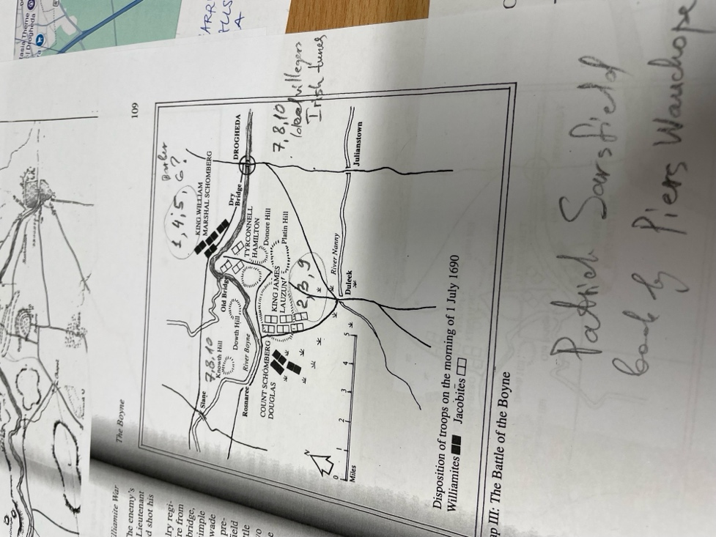
Notes:
- we use battle field effect sound- as an ID Time level of the Battle
- we use 22. Concertina track from Tim Doyle Irish Trad folder as an ID for Time travel modern
- we use 19. Pipes track from Tim Doyle as an ID for Time Travel Celtic Mythology

